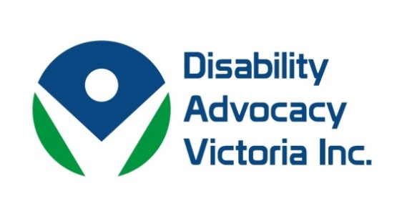

|  |  |  |  |  |
| --- | --- | --- | --- | --- |
| |  |  |  |  | | --- | --- | --- | --- | | |  |  |  | | --- | --- | --- | | |  |  | | --- | --- | | |  | | --- | | Dear Members,   Thanks to all of you who continue to support the work of Disability Advocacy Victoria (DAV).    Disability Advocacy Victoria works to strengthen the disability advocacy sector and raise awareness about the needs and rights of people with disabilities in Victoria.  We would like to inform you of our representation across a number of areas:   **Disability Advocacy Resource Unit**: - Disability Advocacy Victoria holds two positions on the governance group and partner with VCOSS who is the lead agency.   Recently, the governance group sought expressions of interest from interested parties to further help inform the work and reach of the unit across Victoria.   **VicDAN**: a coalition of independent disability advocacy agencies and the Victorian Legal Aid.   This network began with the NDIS pilot in Barwon and has now broadened with the NDIS roll out across the state.  A number of DAV’s membership are involved with VicDAN and recently coordinated a full day forum on ‘Advocacy Matters', exploring the relationship between advocacy and the National Disability Insurance Scheme.  The forum was well attended by the disability advocacy sector, policy staff and legal workers.   **VCOSS Statewide and Peaks Network Forum:** A representative from the DAV Board attends the monthly meeting of this forum to achieve updates on events across the sector.  There has also been a deepening of understanding sought from DAV as a peak in a number of VCOSS consultations involving people with disability.   **The Law Institute of Victoria, Disability Law Committee**: an active committee of the Administrative Law and Human Rights Section, monitoring all areas of law that affect people who have a disability and makes submissions to many government inquiries regarding them.   **Victoria Police Disability Portfolio Reference Group:** is aimed at informing and improving Victoria Police’s interactions with members of the community who have a disability. If your organisation would like to raise any matters regarding the police, you may contact DAV Board members: Deidre Griffiths (deidre.griffiths@villamanta.org.au ) or Julie Philips (manager@ddls.org.au).   **Education** We are pleased to announce that Disability Advocacy Victoria is also currently facilitating the re-establishment of the Inclusive Education Alliance.  The Office for Disability data demonstrates that our membership continues to dedicate significant resources towards inclusive education issues.  DAV is committed to prioritising its systemic work on Education issues.  Please let us know if you would like to get involved.   **Research** Disability Advocacy Victoria is also working in partnership with Federation University on a research project funded by Victorian Legal Service Grants, looking into the experiences of people with complex communication needs who have interacted with the civil or criminal justice system.  For any further information contact DAV Board member: Jan Ashford (jashford@communicationrights.org.au)     **Women with Disabilities Victoria Brenda Gabe Leadership Award**   Women with Disabilities Victoria would like to inform members about nominations for the Brenda Gabe Leadership Award:  Women with Disabilities Victoria (WDV) is excited to announce that nominations for the 2017 Biennial Brenda Gabe Leadership Award are now open. This award recognises and rewards the contribution women with disabilities have made that is of direct benefit to women with disabilities, or to making a more inclusive community, in Victoria.  Please consider nominating a woman with a disability, or a group of women with disabilities, who you know is making a difference.  All award nominees are acknowledged and celebrated at our AGM in October 2017. The winner will receive $2,000 towards professional development, or a capacity building project.  To obtain a brochure, nomination requirements and nomination form contact Bridget Jolley at WDV (see below). For more information about the award or past nominees and award recipients, please visit our website - <http://wdv.org.au/Brenda%20Gabe.html#BGLAtop>, or contact Bridget Jolley at WDV.   E: bridget.jolley@wdv.org.au Ph: (03) 9286 7813 A: GPO Box 1160, Melbourne, Vic, 3001 | | | | |

|  |  |  |  |  |
| --- | --- | --- | --- | --- |
| |  |  |  |  | | --- | --- | --- | --- | | |  |  |  | | --- | --- | --- | | |  |  | | --- | --- | | |  | | --- | | Disability Advocacy Victoria | | | | |