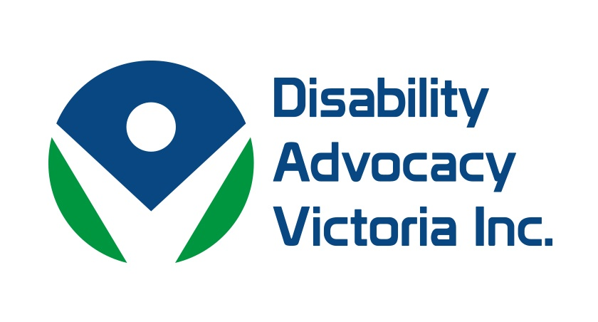
Disabilty Advocacy Victoria Inc.
ANNUAL REPORT 2015–16

ABN 15 557 421 367

4/3 Tuck Street, Moorabbin 3189

Board Members

Melanie Muir Chairperson
Leadership Plus

Esther Harris Treasurer/membership
STAR

Jan Ashford Secretary
Communication Rights Australia

Julie Phillips Systemic Advocacy
Disability Discrimination Legal Service

Deidre Griffiths Board Member
Villamanta Disability Rights Legal Service Inc.

Staff
Kerry O’Hagan Administration (current)
Louise Hird Administration (September 2015 – Feb 2016)

Chairperson Report
We would like to thank our members for their commitment and support to the values and work of Disability Advocacy Victoria.
This year saw the roll out of the NDIS begin and as such the Barwon Disabilty Advocacy Network became the Victorian Disability Advocacy Network (VicDAN), where the disability advocacy sector collaborates with the legal sector to address issues related to the NDIS.
Following the National Disability Advocacy Framework Review was the National Disability Advocacy Program (NDAP) Review where DAV continued to build its relationship with the Disability Advocacy Resource Unit (DARU) and the Victoria Council of Social Service (VCOSS) resulting in a joint submission made. Outcomes from the NDAP review are scheduled for the end of 2016.
DAV has also continued it’s systemic focus on education with further submission made regarding the Program for Students with Disabilities. Comment was also made on the New DET Restrictive Practice/Behaviour Policies October 2015.

DAV worked with VCOSS in highlighting the need for continued funding for independent disability advocacy and the Program for Students with Disabilities in relation to the VCOSS Budget Submission. DAV also sit on the governance board of DARU with VCOSS and the Strengthening Disability Advocacy Conference Committee. DAV are also represented when the Inclusive Education Alliance meet.
This year also saw DAV commence research collaboration with the Federation University with three research topics:
1. Experiences of people who use alternative forms of communication in court, with Dr Marg Camilleri, who further investigates the question; the needs of people with complex communication needs in their interaction with the criminal and civil justice system.
2. Issues experienced by parents with disability in the child protection system with Dr Angel Murphy – the lack of timely, coordinated response to the specific support needs of parents with a disability.
3. Experiences of young people with disabilities who are in the education system and their contact with the justice system, with Dr Jenene Burke and Dr Marg Camilleri.

Continued submissions made in relation to the significant concerns around the abuse and neglect of people with disability
- Supplementary Submission into Inquiry in to Abuse in Disability Services (July 2015)

- Inquiry into Abuse in Disability Services
  - Ombudsman's Report Phase 1

While DAV has limited resources, the Board continues to maximise our ability to inform our membership by way of keeping the DAV website up to date. We are also keen to highlight the important work of our member agencies. All of the submissions made by DAV can be found on our website, see:
www.disabilityadvocacyvictoria.org.au

